Abstract

[Draw your reader in with an engaging abstract. It is typically a short summary of the document.   
When you’re ready to add your content, just click here and start typing.]

Sustainability measures for energy systems

CASE STUDY

Introduction:

As the population of the world continues to rise, energy demands have sharply increased. In conjunction with the increasing standard of living and consumer demands, current carbon emissions have become unsustainable. In Australia, energy production mainly relies on non-renewable sources, with coal and gas accounting for approximately 79% (Energy, 2020). It is necessary for alternative energy generation methods that are greener and have lower carbon intensities to be used.

In this report, the energy flows and carbon intensity of two contemporary low emission electricity production choices are compared:

1. High Efficiency, Low Emissions (or HELE for short) power plants and,
2. PV Solar using pumped hydro storage

Although both methods have many advantages and disadvantages, this report will only use the energy flows and carbon intensity of each energy generation system to evaluate and compare. Energy flows between subsystems were researched and calculated to show the overall efficiency of each energy generation method. Based on a 20-year lifespan expectancy, the carbon intensity of $CO_{2}$ emissions were explored. This was calculated by considering the total emissions from each subsystem. It was concluded that 5.09 MWh of thermal input was required to supply consumers with just 1 MWh of energy for the PV Solar

Energy Flows:

To best compare the energy flows and differences of HELE power plants and Solar PV using pumped hydro storage, it was assumed each energy generation system to deliver 1 MWh of electricity of customer. By working backwards and using researched literature, the efficiency and the amount of energy transfers required were calculated in shown in the figure below. There are four main components of a HELE power plant from which can be used to illustrate the energy flow from converting the coal into usable electrical power:

1. Furnace which combusts coals and acts as a boiler to provide heat into the system,
2. Power Station heat engine that converts the heat energy into shaft work,
3. Generator that turns the input shaft work into electrical power, and
4. Grid where the electricity is distributed

The assumptions were made that the change in kinetic energy and potential energy is negligible. Also, that all system is at steady state. All data values used in the calculations can be found in the appendix. Through literature search, it was found that the electrical efficiency of the grid to be around 93%, the generator to be approximately 0.97% efficient, the HELE power plant to be about 50% efficient, with coal having an energy density of 30MJ/kg. As a result, it is estimated that about 267.92kg of coal is needed to produce 1MWh of usable electrical energy to customers. This energy flow of the HELE power plants, with its main components is show in figure 1.

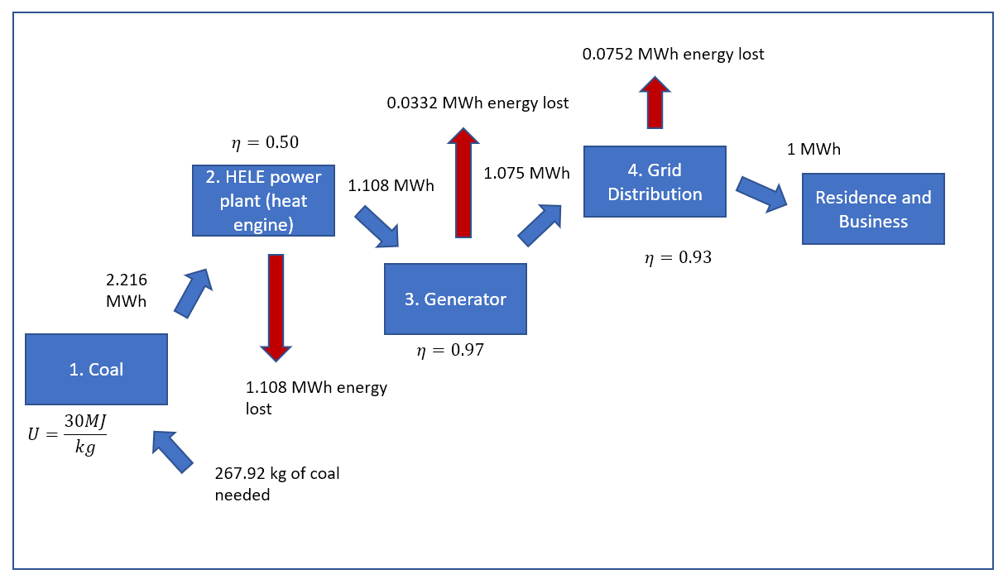

Figure : Illustration showing the energy flow for HELE power plant (appendix for sources)

Table 1 shows the assumptions for the PV Solar and pump hydroelectric power plants and their respective justifications.

Table : Assumptions and Justifications for Energy Flows

|  |  |
| --- | --- |
| **Assumption** | **Justification** |
| Energy supply methods remain constant. | It would be counterproductive to produce different transmission wires for each section of the power plant. All electricity should therefore flow on the same wires. |
| Energy losses from new PV solar farm to hydroelectric plant are negligible (losses come from distribution network: cables, transformers). | Initial construction engineers would have ensured energy losses remain minimal to enhance production and maximise efficiency. |

Figure : Energy Flow Diagram (with losses)

Carbon Intensity:

The carbon intensity of both energy generation option is also analysed and compared. Both methods produce CO2e emission and can be broken down mainly into the primary emissions from energy generation, embedded emissions in fuels, embedded emissions in the generators, and finally the emissions of the grid distribution.

Figure 3 is a quantitative model for the energy input to the PV Solar Hydroelectric Power Plant to produce 1 MWh to the consumer.

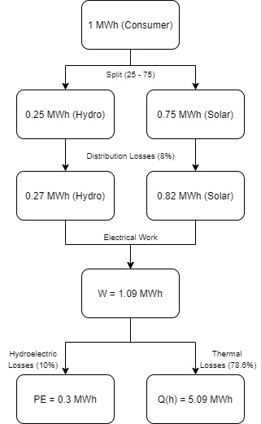

Figure 3: Energy FLow Diagram (per 1 MWh)

This model indicates significant input requirements per unit output. The most impactful loss is in thermal energy losses, due to the severe inefficiency of solar power. However, this technology is relatively new and still developing rapidly. It is likely that these figures will change dramatically over time and become far more energy efficient.

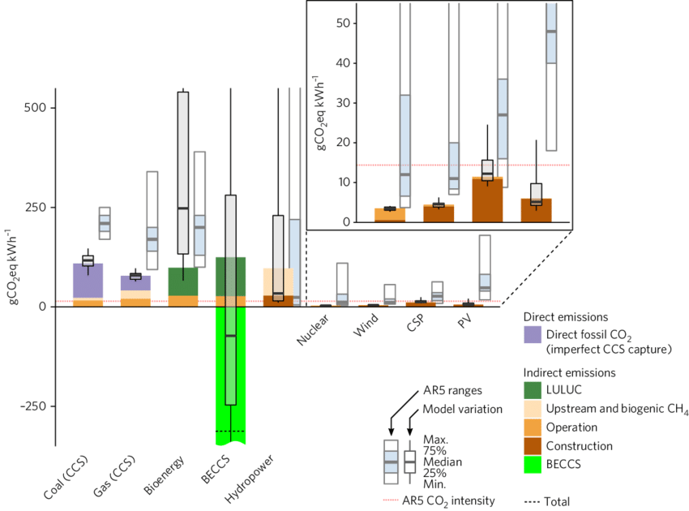

Figure L Lifecyle Emissions of Various Energy Producers (Pehl et al. 2017)

Figure 4 demonstrates the abundantly low emissions for PV solar hydro. Indirect emissions from hydroelectricity are from methane and are out of scope for this report. Therefore, ALL emissions from these technologies can be accounted for by construction (and operation) which, when factoring the renewable nature of the systems, indicates net zero emissions (Pehl et al. 2017). To determine total carbon intensity of this system, it will be assumed that embedded energy in the grid is % greater than construction (Denholm and Kulcinski, 2003).

Table : Carbon Emissions of PV Solar and Pumped Hydro

|  |  |  |  |
| --- | --- | --- | --- |
| **Emissions Factor** | | **Solar** | **Hydro** |
| Direct (kg CO2 / MWh | | 0 | 0 |
| Indirect (kg CO2 / MWh) | Construction | 60 | 132.5 |
| Embedded in Grid | 63.6 | 140.5 |
| **Total** | | 396.6 (kg CO2 e/ MWh) | |

Insert Comparison of Carbon Intensity Chart:

Reference List:

1. A technology roadmap for high-efficiency, low-emissions (HELE) coal-fired power plant | IEA Clean Coal Centre. (2020). Retrieved 30 October 2020, from https://www.iea-coal.org/webinar/a-technology-roadmap-for-high-efficiency-low-emissions-hele-coal-fired-power-plant/

#### (EESI), E. (2019). Fact Sheet: Energy Storage (2019) | White Papers | EESI. Retrieved 30 October 2020, from <https://www.eesi.org/papers/view/energy-storage-2019>

#### Frequently Asked Questions (FAQs) - U.S. Energy Information Administration (EIA). (2020). Retrieved 30 October 2020, from <https://www.eia.gov/tools/faqs/faq.php?id=105&t=3#:~:text=The%20U.S.%20Energy%20Information%20Administration,annually%20in%20the%20United%20States.&text=EIA%20has%20estimates%20for%20total,in%20the%20State%20Electricity%20Profiles>.

#### Loss Factors and Regional Boundaries. (2020). Retrieved 30 October 2020, from <https://www.aemo.com.au/-/media/Files/Electricity/NEM/Security_and_Reliability/Loss_Factors_and_Regional_Boundaries/2019/DRAFT-Marginal-Loss-Factors-for-the-2019-20-Financial-Year.pdf>

#### METI (2013) Advancing Highly Efficient Technology and Environmental Performance. Available from: www.meti.go.jp/english/publications/pdf/journal2013_10a.pdf Ministry of Economy, Trade and Industry of Japan (2013)

#### Zhu Q (2016) China – policies, HELE technologies and CO2 reduction, IEA Clean Coal Centre CCC/269 (September 2016)

#### Electricity Generating and Distribution Efficiency. (2020). Retrieved 30 October 2020, from https://www.mpoweruk.com/energy_efficiency.htm

#### Distribution grid efficiency assessment grading research based on AHP - IEEE Conference Publication. (2020). Retrieved 30 October 2020, from <https://ieeexplore.ieee.org/document/6991956>

#### Heat values of various fuels - World Nuclear Association . (2020). Retrieved 30 October 2020, from https://www.world-nuclear.org/information-library/facts-and-figures/heat-values-of-various-fuels.aspx

#### Fuels - Higher and Lower Calorific Values. (2020). Retrieved 30 October 2020, from <https://www.engineeringtoolbox.com/fuels-higher-calorific-values-d_169.html>

#### (2020). Retrieved 30 October 2020, from https://www.environment.gov.au/system/files/resources/5a169bfb-f417-4b00-9b70-6ba328ea8671/files/national-greenhouse-accounts-factors-july-2017.pdf

Appendix A: Energy Flow Analysis Data

|  |  |  |
| --- | --- | --- |
| Data | Uncertainty | References |
| Electrical Efficiency of the grid distribution $η=0.93$ | **Moderate:**  Varies between sources. Heavily depends on other factors such as size of grid and distance from plant to residence | (EIA (US Energy Information Administration, 2018)), 95%  (Liu & Wang, 2014), 90% |
| Electrical Efficiency of Generator (shaft work to electrical) $η=0.97$ | **Low:**  Although this varies between generators, the values are all within similar range | (Woodbank Communications Ltd, 2005), 0.98 – 0.97  (Nguyen, 2015), 0.97 |
| Efficiency of HELE power plant $$η=0.50$$ | **Low:**  Current HELE plants mostly exhibit roughly the same efficiency. | (IEA Clean Coal Centre, 2020), 47.8 – 49.1%  (Lockwood, 2020), 50% |
| Internal Energy density contained in coal $$U=30 MJ/kg$$ | **Moderate:** Varies between difference sources. Coals have different properties around the world. Difficult to measure and quantify. | (World Nuclear Association, 2018), 25MJ/kg  (Engineering Toolbox, 2008), 34.6MJ/kg |
| Solar panel efficiency = 21.4%  Range: 20.2 – 22.6% | **Low:**  Efficiency (solar) is limited by current technology constraints. Hydroelectricity has an efficiency benchmark of 90% and cannot exceed 100 | (Jason Svarc, 2020) |
| Hydroelectric efficiency = 90%  Range: ≥90% | (Australian Water Association, 2012),  USBR, 2005 |
| Energy losses in distribution (plant to consumer) = 8%  Range: 6 – 10% | **Low:**  Energy losses are determined by infrastructure choices. Losses are measurable by comparing the amount of energy leaving the plant and amount reaching consumers; these are considered by suppliers during design. | (International Electrotechnical Commission, 2007 ) |

Appendix B: Carbon Intensity Analysis Data

|  |  |  |
| --- | --- | --- |
| Data | Uncertainty | References |
| Primary CO2e emissions from energy generation  Assume supercritical:  ~ 730.43 CO2e kg/MWh | **Moderate:**  Depends heavily on specific type of HELE power plant and other factors. However, closely matches the range of many HELE powers plants | (IEA Clean Coal Centre, 2020),  Sub-critical: 798.59-807.32 CO2e kg/MWh  supercritical: 726.48-734.38 CO2e kg /MWh |
| Embedded CO2e emission in coal fuel:  ~23 kg CO2e /MWh | **High:**  Not much information about. Magnitude of value is significantly less than primary emissions. This makes it negligible overall. Varies greatly depending on circumstances and locations. | (Quaschning, 2016) |
| Embedded CO2e emission in the generator:  ~negligible | **Low:**  HELE produce negligible CO2e emissions within the system as by design. | (METI,2013) |
| Embedded CO2e Emission of the grid:  ~800 CO2e kg/MWh | **High:**  Vague estimate. Energy loss of grid distribution is usually not measured to CO2e. Depends on location and build. | (Department of Environment and Energy, 2017), ~800CO2e kg/MWh |